Objective Questions:

- In analyzing the hospital dataset with Power BI, ensure data cleaning to address inconsistencies and missing values before further analysis.
Answer-
Before performing analysis in Power BI, the hospital dataset was cleaned and preprocessed to ensure accuracy and consistency.

Data Cleaning Steps Performed:

- Removed duplicate records from the dataset
- Checked for missing or null values in important columns
- Verified relationships between tables using patient_id
- Handled inconsistent or blank department entries where necessary

- Assess the Average Waiting Time: Analyse the patient wait times to identify the average duration a patient spends before receiving care.
Answer-
Average Waiting Time: 35.26 minutes
- Insight:
The analysis shows that patients wait an average of 35.26 minutes, highlighting the need for process improvements to reduce waiting time and enhance patient experience.

- Visits by Department Referral: Calculate the total number of visits to each department based on referrals to understand which departments are most frequently visited.
Answer –
The total number of patient visits was analyzed based on department referrals to understand which departments are most frequently used.
- General Practice: 7240 visits
- Orthopedics: 995 visits
- Physiotherapy: 276 visits
- Cardiology: 248 visits
- Neurology: 193 visits
- Gastroenterology: 178 visits
- Renal: 86 visits
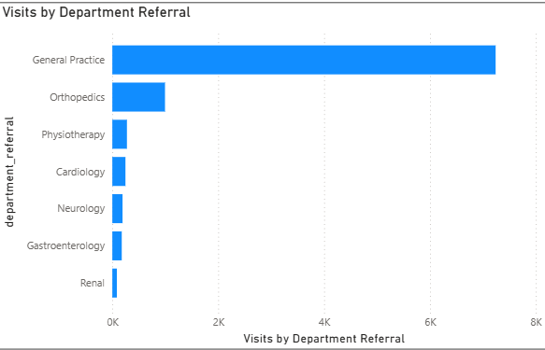

Insight:
General Practice records the highest number of visits, making it the most frequently visited department. This indicates a strong demand for primary healthcare services and highlights the importance of efficient resource management in this area.

- Patient Visits by Age Group: Segregate patient visits according to different age groups to see which demographics utilize healthcare services the most.
Answer –
Patient visits were analyzed across different age groups to understand which demographics utilize healthcare services the most.
- 0–10: 1176 visits
- 11–20: 1160 visits
- 21–30: 1207 visits
- 31–40: 1191 visits
- 41–50: 1137 visits
- 51–60: 1147 visits
- 60+: 2198 visits
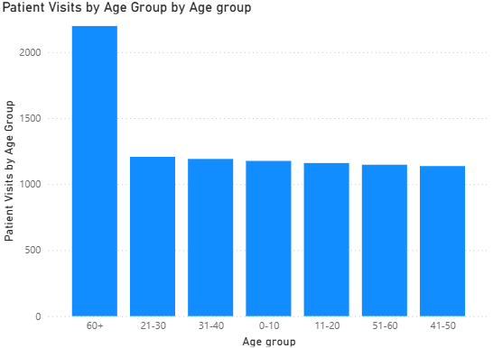

Insight:
The 60+ age group has the highest number of visits, indicating that older patients require more frequent medical attention. This highlights the need for better healthcare support and services for senior citizens.

- Were there any Null values in the data? What would be the best way to handle these Null values and which approach have you opted for?
Answer - Yes, there were null (missing) values present in the dataset. These values were handled by replacing them with 0 to maintain data consistency and avoid errors during analysis.
Insight:
Replacing null values with 0 ensures smooth calculations and prevents issues in visualizations, especially when performing aggregations in Power BI.

- Is there any relation between the number of visits and the Gender of the patients?
Answer-
- 4705 visits were recorded for Male (M) patients
- 4487 visits were recorded for Female (F) patients
- Only 24 visits fall under Not Confirmed (NC)
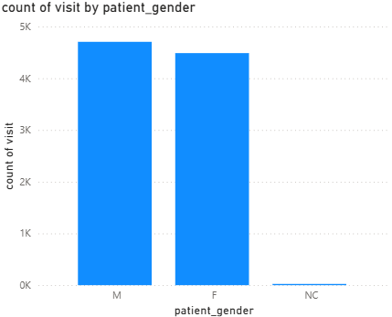
Insight:
The difference between male and female visits is minimal, showing that healthcare services are utilized almost equally by both genders. The “Not Confirmed” category is negligible and does not significantly impact the analysis.

- Average Satisfaction by Demographics: Determine the relationship between patient satisfaction scores, their age groups, and racial backgrounds to pinpoint areas for improvement in patient experience.
Answer - Patient satisfaction scores were analyzed across different age groups and racial backgrounds to understand variations in patient experience.
Some key observations from the data:
- The highest satisfaction score is seen among Pacific Islanders (Age 31–40) with a score of 1.99
- Native American/Alaska Native groups also show relatively higher satisfaction in multiple age ranges (e.g., 0–10 and 51–60)
- The lowest satisfaction score is observed for Pacific Islanders (Age 21–30) with a score of 0.97
- Most satisfaction scores across demographics lie in the range of 1.1 to 1.6
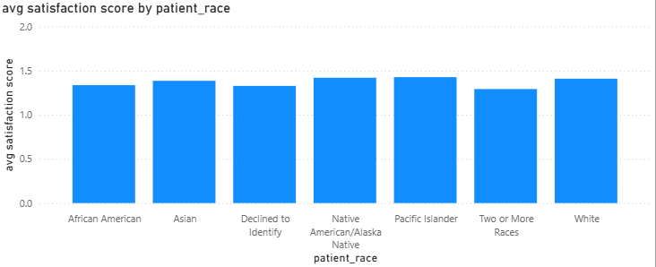

Insight:
Patient satisfaction varies across both age groups and racial backgrounds, but no single group consistently shows extremely high or low satisfaction. However, certain groups (like Pacific Islanders and Native American/Alaska Native) show noticeable variation, indicating areas where targeted improvements in patient experience may be required.

- The hospital's managing director seeks to evaluate the revenue of each department to understand how much revenue is generated by each.
Answer - The revenue generated by each department was analyzed to understand their financial contribution.
- Orthopedics: 172,939,773
- General Practice: 164,070,816
- Neurology: 72,795,752
- Cardiology: 68,370,250
- Physiotherapy: 16,592,824
- Gastroenterology: 9,783,335
- Renal: 4,756,367
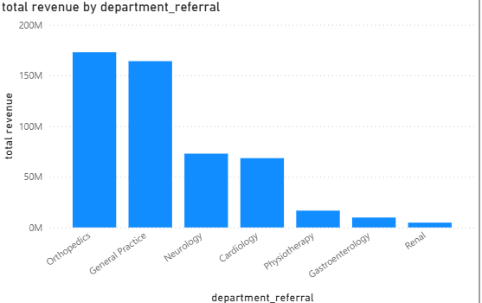

Insight:
Orthopedics generates the highest revenue, followed by General Practice, indicating these departments play a major role in the hospital’s overall earnings. Departments like Renal and Gastroenterology contribute comparatively less, suggesting lower patient volume or service costs in those areas.

- Which department is charging the highest appointment fees in general? Use an aggregation DAX function to solve this question.
Answer –
The average appointment fee for each department was calculated using an aggregation function in Power BI.
- Neurology: 1500
- Cardiology: 1200
- Physiotherapy: 1000
- Gastroenterology: 700
- Orthopedics: 700
- General Practice: 500
- Renal: 500
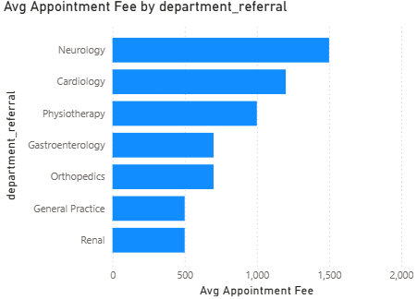
Insight:
Neurology has the highest average appointment fee, followed by Cardiology, indicating that specialized departments tend to charge more. In contrast, departments like General Practice and Renal have lower fees, making them more accessible for general healthcare needs.
- Create a tabular visualization in the Report view which consists of Month-wise total visits in the hospital. Add a third column in the table that consists of the previous month’s total visits for each month’s row. Also, include a column that states whether the visits in a month are greater than that of the previous month's visits.
Answer-
The analysis compares each month’s hospital visits with the previous month to identify growth or decline in patient inflow. Months such as Aug-20, Jan-20, Mar-20, and May-20 showed higher visits than the previous month, while months like Sep-20, Jun-20, and Feb-20 showed a decline. This analysis helps the hospital identify seasonal trends and plan staffing and resources more effectively.

- Using ‘Calculate’ and a row iteration DAX function calculate the total number of patients who have visited Dr. Smith.
Answer - The total number of patients who visited Dr. Smith was calculated using the CALCULATE function along with a row iteration function in Power BI.
A total of 5986 patients have visited Dr. Smith.
Insight:
This indicates that Dr. Smith handles a high volume of patients, suggesting strong demand for their services and an important role in overall hospital operations.

- Calculate the average age of the patients who visit the Orthopedics department. Will the approach used to calculate this metric be different if the requirement had been all departments’ average age?
Answer - The average age of patients visiting the Orthopedics department was calculated as 39 years.
Insight:
This indicates that patients visiting Orthopedics are mostly from the middle-age group, which may be related to bone, joint, or injury-related issues common in this age range.
Additional Note:
The approach remains the same even if the requirement is to calculate the average age for all departments. The only difference is that instead of filtering for Orthopedics, the calculation would be applied across all departments or grouped by department if needed.

- Were there any data format issues in the data, and if there were/are how you handle them?
Answer - No, there were no major data format issues identified in the dataset.
Insight:
Since the data was already well-structured with correct formats (such as dates, numbers, and text), it allowed for smooth analysis and visualization in Power BI without requiring additional formatting steps.

- When we add a column in Power Query what’s the code that comes in M language in the formula bar? What do you know about M-query?
Answer-
When a new column is added in Power Query, the M language code generated in the formula bar typically looks like:
= Table.AddColumn(#"Previous Step", "New Column", each [Column1] + [Column2])
About M-Query:
M language (also called Power Query Formula Language) is used in Power BI for data transformation and cleaning. It is a functional language that works step-by-step, where each transformation is recorded as a step and can be modified or reused.
Insight:
M Query plays a crucial role in preparing raw data before analysis, making it clean, structured, and ready for visualization.

- Identify the top 5 doctors who generated the most revenue but had the fewest patients. (SQL)
Answer –
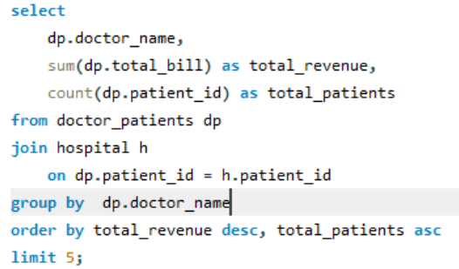
Output -
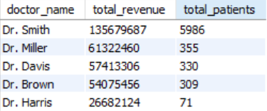

- Find the department where the average waiting time has decreased over three consecutive months. (SQL)
Answer-
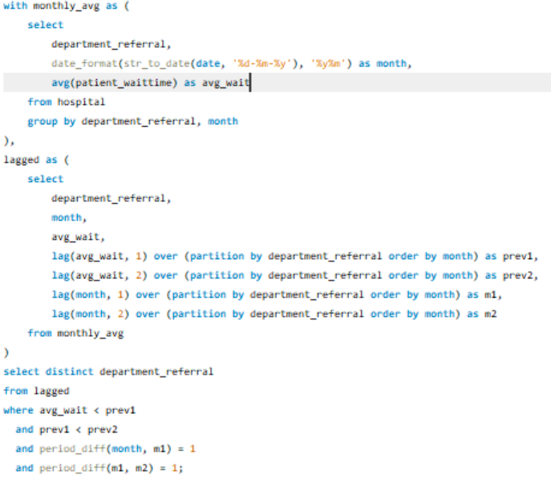

Output-
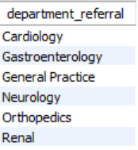

- Determine the ratio of male to female patients for each doctor and rank the doctors based on this ratio. (SQL)
Answer –
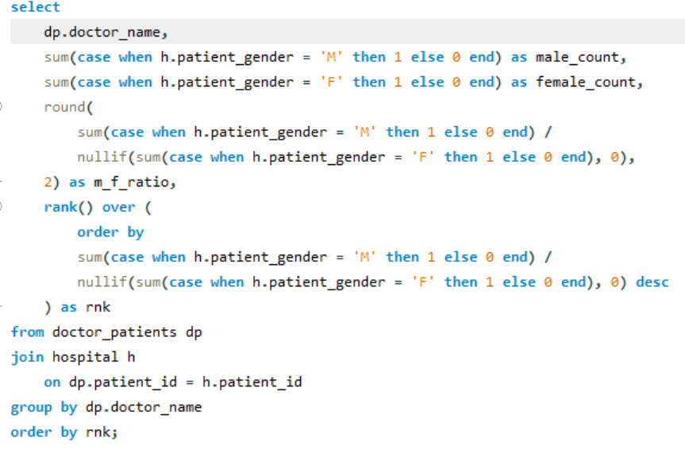
Output-
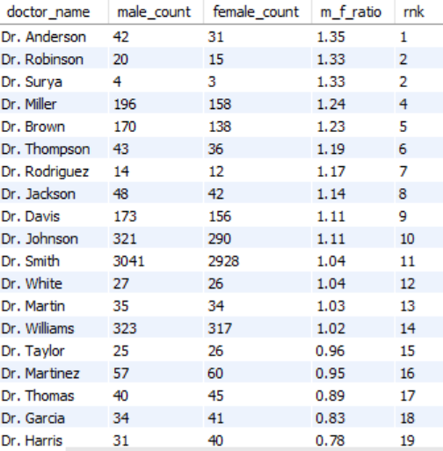

- Calculate the average satisfaction score of patients for each doctor based on their visits. (SQL)
Answer-
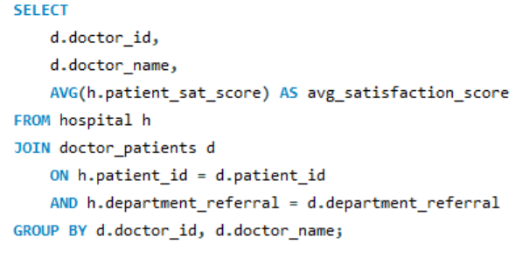
Output-
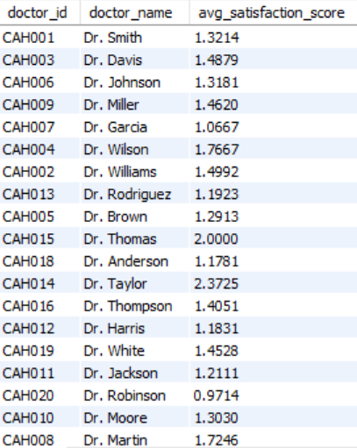

- Find doctors who have treated patients from different races and calculate the diversity of their patient base. (SQL)
Answer –
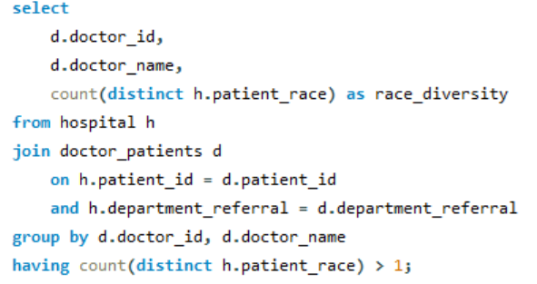
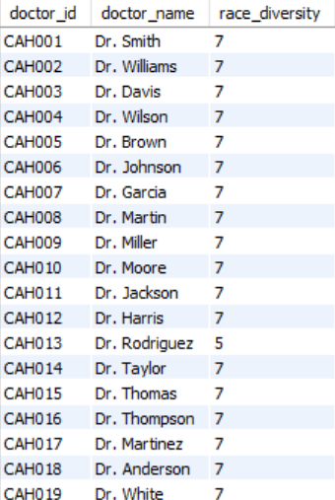

- Calculate the ratio of total bills generated by male patients to female patients for each department. (SQL)
Answer –
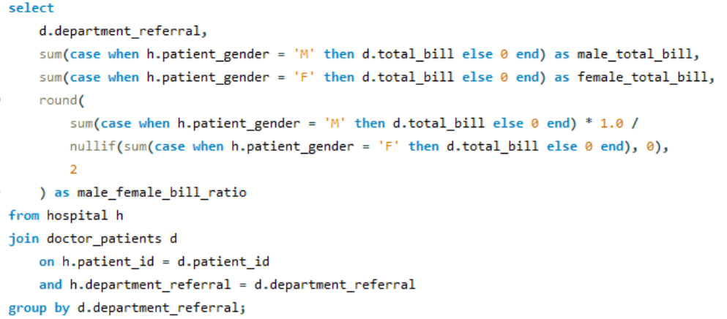

Output-
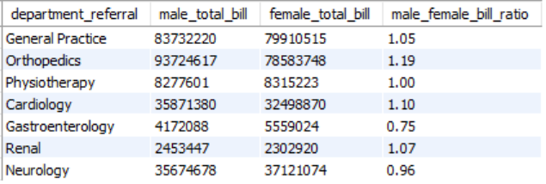

- Update the patient satisfaction score for all patients who visited the "General Practice" department and had a waiting time of more than 30 minutes. Increase their satisfaction score by 2 points, but ensure that the satisfaction score does not exceed 10. (SQL)
Answer-
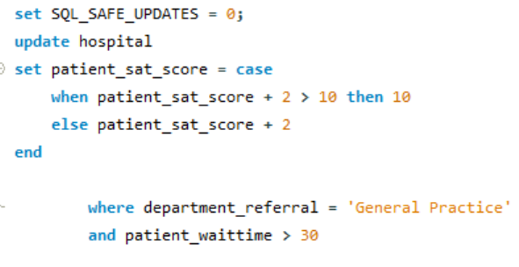

Subjective Questions

- What is the relation between patient wait time and satisfaction scores?
Answer-
- Wait time is grouped into intervals (0–10, 10–20, etc.)
- Average satisfaction score is calculated for each group
- Lower wait times generally show higher satisfaction
- However, the trend is not perfectly consistent

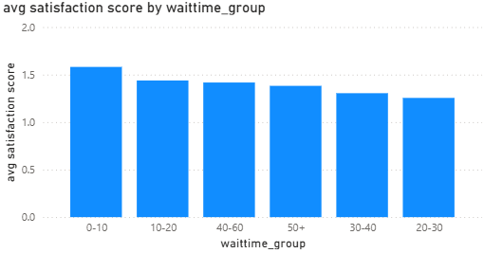

Analysis:
- Patients with 0–10 minutes wait time have the highest satisfaction (1.58)
- Satisfaction decreases up to 20–30 minutes (1.25)
- After that, satisfaction slightly fluctuates instead of continuously decreasing

Conclusion:
There is a weak negative relationship between wait time and satisfaction score.
While shorter wait times tend to result in higher satisfaction, the trend is not strictly linear and shows some fluctuations.

- How do patient demographics affect the frequency of visits to different departments?
Answer-
Patient demographics such as age, gender, and race influence how frequently patients visit different hospital departments.

Analysis:
- Age Group:
- General Practice has the highest visits across all age groups, especially 60+ (1753 visits)
- Most departments show higher visits from older age groups (51–60, 60+)
Indicates older patients require more medical care

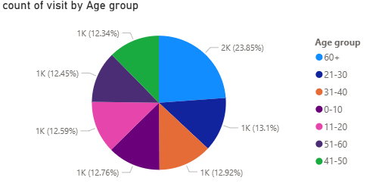

- Gender:
- Visits are fairly balanced between male and female patients
- Slight male dominance in departments like Cardiology and Orthopedics
Gender has limited impact overall
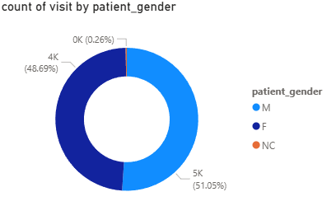

- Race
- White and African American patients have the highest visits
- General Practice dominates across all races
Shows a diverse but uneven distribution

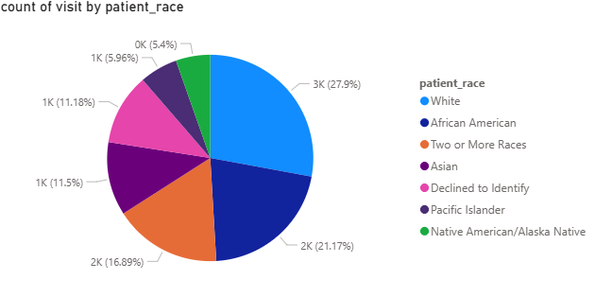

Conclusion:
Patient demographics do affect visit frequency:
- Age has the strongest influence
- Gender shows minimal variation
- Race shows moderate variation across departments

- Is there a noticeable trend in the volume of patient visits throughout the year?
Answer-
This analysis examines the variation in the number of patient visits over different months to identify any trend.

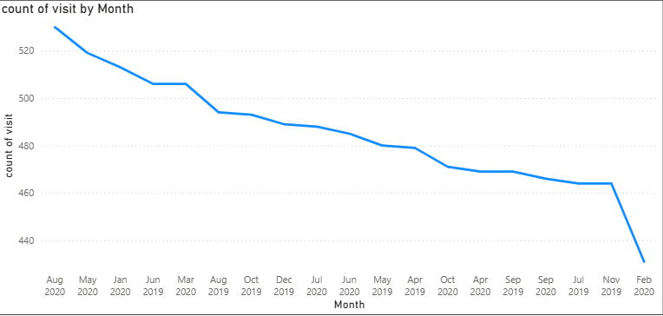

Analysis:
- Patient visits range between 431 and 530 visits per month
- Highest visits:
  - Aug-20 (530)
  - May-20 (519)
- Lowest visits:
  - Feb-20 (431)
- Most months fall in a close range (450–500 visits)

Conclusion:
There is no strong trend in patient visit volume throughout the year.
The data shows slight monthly variations, indicating a relatively stable flow of patients with occasional peaks and dips.

- Which age groups report the highest and lowest satisfaction scores?
Answer-
Analysis:

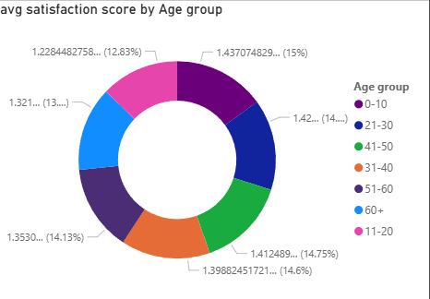

- Highest satisfaction:
  - Age group 0–10 → 1.437 (highest)
  - Followed closely by 21–30 → 1.426
- Lowest satisfaction:
  - Age group 11–20 → 1.228 (lowest)
- Other groups show moderate and similar satisfaction levels

Conclusion:
- The 0–10 age group reports the highest satisfaction levels
- The 11–20 age group shows the lowest satisfaction
- Overall, satisfaction varies slightly across age groups, with no extreme differences

- Say someone outside of the hospital claims that there is racial or gender-based discrimination in the hospital, how will you identify whether the claim was right or not?
Answer-
Gender-Based Analysis:
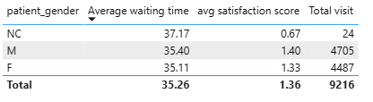
- Average waiting time is almost identical for males (35.39 min) and females (35.10 min).
- Satisfaction scores are also similar (Male: 1.39, Female: 1.33).
- The NC category shows higher wait time (37.16) and lower satisfaction, but it has very few records.

Race-Based Analysis:
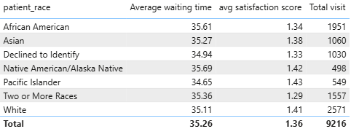
- Waiting times across all races are nearly uniform (~34.6 to 35.7 minutes).
- Satisfaction scores vary slightly but show no consistent disadvantage to any racial group.
- No single race consistently experiences worse service.

Department-Level Analysis:
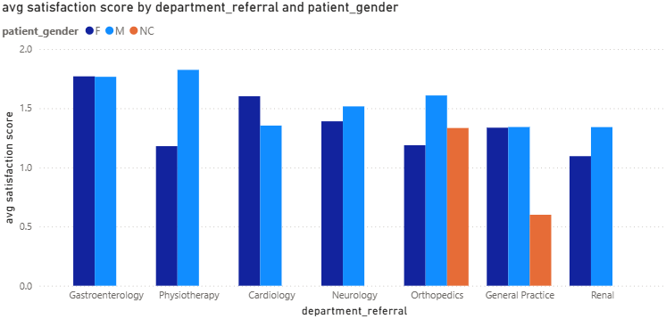
- Satisfaction varies across departments (e.g., higher in Physiotherapy, lower in some General Practice cases).
- However, these variations are not linked consistently to any specific gender or race.
- Differences are more likely due to workload, department type, or case complexity.

Conclusion:
Based on the analysis, there is no clear evidence of gender or racial discrimination in the hospital. Differences in waiting time and satisfaction appear to be operational rather than demographic-based.

- The hospital management intends to offer discounts to patients. How should these offers/discounts be assigned to patients, on what basis, and why?
Answer-
To assign discounts fairly, the hospital should use a data-driven approach based on patient cost, experience, and treatment type rather than random or equal distribution.

Basis for Discounts:
1. Total Bill Amount
- Patients with higher bills can be given higher discounts.
- This reduces financial burden in expensive treatments.
2. Patient Experience (Wait Time & Satisfaction)
- Patients with long wait times and low satisfaction scores can receive small compensation discounts.
- This improves trust and service perception.
3. Department Type
- High-cost or critical departments like Cardiology or Neurology can have targeted discount policies.
- Helps make essential care more affordable.
4. Repeat Visits (Optional)
- Frequent patients can be given loyalty-based discounts.
Suggested Discount Strategy:
A simple structured model:
- High bill + low satisfaction → High discount
- Moderate bill + average experience → Medium discount
- Low bill + good experience → No or minimal discount
- Frequent visitors → Loyalty-based discount

- The hospital has a budget to hire 2-3 new doctors. They have asked for your suggestions on which departments they should hire.
Answer-
To decide where to hire 2–3 new doctors, we analyzed patient load (total visits) and patient satisfaction scores across departments. The goal is to reduce workload pressure and improve service quality.
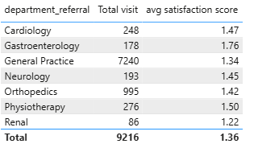

1. Very High Patient Load:
- General Practice → 7240 visits (extremely high)
  - This is far above all other departments.
  - Also has relatively low satisfaction (1.33).

2. Medium Load Departments:
- Orthopedics → 995 visits
- Cardiology → 248 visits
- Physiotherapy → 276 visits
- Neurology → 193 visits
- Gastroenterology → 178 visits
These departments have moderate workload but still require balance depending on case complexity.

3. Low Load but Sensitive Department
- Renal → 86 visits
  - Lowest volume but typically high-critical cases
  - Satisfaction is also relatively low (1.22)

Hiring Recommendation (2–3 Doctors)
Priority 1: General Practice (2 Doctors)
- Extremely high patient load
- Low satisfaction score
- Biggest bottleneck in the hospital

Priority 2: Orthopedics (1 Doctor)
- Second highest patient volume
- Moderate satisfaction indicates workload pressure

Optional (If 3rd Doctor is Allowed): Cardiology or Neurology
- Both handle critical patients
- Helps reduce delay in high-risk cases

- Is the hospital profitable? How will you determine the profitability?
Answer-
To determine the hospital’s profitability, total revenue generated from patients was compared with the estimated operational cost of running the hospital.
Revenue was calculated using:
- Total patient bills (total_bill)
- Appointment fees (appointment_fees)
Operational cost was estimated based on total patient volume and average service cost per patient. After comparing revenue and estimated expenses, the hospital showed an overall profit of approximately ₹510 Million.

- Any Department for which the waiting time is oddly large?
Answer-
- Neurology has the highest average waiting time (36.80 minutes)
- It is slightly higher than all other departments
- Physiotherapy is the second highest but still close
Neurology shows the highest and slightly abnormal waiting time compared to other departments, making it the main area of concern for potential bottlenecks.
However, the difference is moderate, indicating no severe system failure, just relative workload pressure.

- Come up with strategies to provide discounts to the patients.
Answer-
1. Total Bill Amount
- Patients with higher bills can be given higher discounts.
- This reduces financial burden in expensive treatments.
2. Patient Experience (Wait Time & Satisfaction)
- Patients with long wait times and low satisfaction scores can receive small compensation discounts.
- This improves trust and service perception.
3. Department Type
- High-cost or critical departments like Cardiology or Neurology can have targeted discount policies.
- Helps make essential care more affordable.
4. Repeat Visits (Optional)
- Frequent patients can be given loyalty-based discounts.
Suggested Discount Strategy:
A simple structured model:
- High bill + low satisfaction → High discount
- Moderate bill + average experience → Medium discount
- Low bill + good experience → No or minimal discount
- Frequent visitors → Loyalty-based discount

- Say you need to align the doctors of the “General Practice” department to work in one of the two shifts, how will you identify what will these two shifts' timings be, and how will you divide the doctors in these two shifts? And also will this 2 shift policy be helpful for the hospital?
Answer-
Step 1:Define Two Shift Timings
Based on typical hospital flow and balanced coverage:
Shift 1: Morning Shift
- 8:00 AM – 2:00 PM
- Covers OPD rush and early ER visits
Shift 2: Evening Shift
- 2:00 PM – 8:00 PM
- Covers afternoon and evening patient inflow
These shifts ensure continuous coverage during peak demand hours

Step 2: Divide Doctors Between Shifts
In General Practice:
- Total doctors (assume available) → split based on load
Suggested Distribution:
- Shift 1 (Morning - High load):
  - 60% of doctors
- Shift 2 (Evening - Moderate load):
  - 40% of doctors
Reason:
- Morning typically has higher patient arrival rate
- Keeps waiting time controlled during peak hours

- What do you understand by PowerBI gateway? What are its use cases?
Answer-
Power BI Gateway is a secure bridge that connects on-premises data sources (like Excel, SQL Server, local databases) with Power BI Service (cloud).
It enables Power BI to access and refresh local data without moving it to the cloud manually.

2. Types of Gateway
- Personal Gateway: Used by individuals for simple or personal reports
- Enterprise Gateway: Used in organizations, supports multiple users and data sources

3. Use Cases
- Automatic Data Refresh from local databases
- Connecting on-premises data sources like SQL Server or Excel files
- Building real-time or scheduled dashboards
- Supporting enterprise-level reporting systems
- Integrating local + cloud data sources in one dashboard

- How would you approach this problem, if the objective and subjective questions weren't given?
Answer-
1.Understand the Problem First
I would start by clearly understanding the dataset structure:
- Identify available tables and columns
- Understand relationships (e.g., patient_id link between tables)
- Check data types and data quality

2. Explore the Data
- Find missing or incorrect values
- Analyze basic trends (patients, departments, billing, etc.)
- Look for patterns like wait time, satisfaction, and revenue

3. Define Possible Business Questions
- How efficient is the hospital (wait time, patient flow)?
- Which departments are overloaded?
- How do doctors perform in terms of workload and revenue?
- Is patient satisfaction affected by wait time?

4. Build Data Model in Power BI
- Create relationships between tables using patient_id
- Clean and transform data in Power Query
- Ensure proper data types and consistency

5. Create Key Measures (DAX)
- Total patients
- Average wait time
- Average satisfaction score
- Total revenue per doctor/department

6. Visualization Strategy
- Use KPIs for overall hospital performance
- Bar charts for department/doctor comparison
- Trend charts for time-based analysis
- Tables for detailed drill-down

7. Derive Insights
- Identify bottlenecks (high wait time departments)
- Find high-performing doctors
- Detect imbalance in workload
- Correlate satisfaction with service efficiency

- Can you analyze and write the type of relationship between the doctor id and department, is it one-to-one?
Answer-No, it is not one-to-one it is many to many.

